REMOTE PATIENT MONITORING SYSTEM
CS-212 Object Oriented Programming Assingment

1. SYSTEM OVERVIEW
--------------------------------------------------
A Java implementation of a hospital management system featuring:
• Patient health monitoring (vitals tracking)
• Doctor appointment scheduling
• Medical prescription management
• Administrator controls

3. INSTALLATION
--------------------------------------------------
Requirements:
- Java JDK 8+
- 500MB disk space

Steps:
1. Compile all .java files
> javac *.java
2. Run Main class
> java Main

4. USER MANUAL
OUTPUT
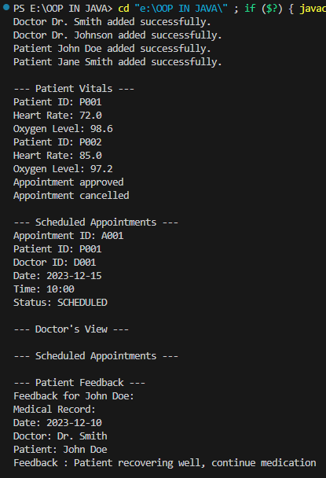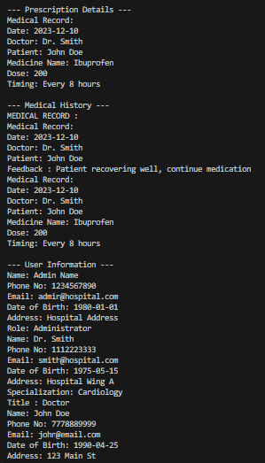

5. TECHNICAL SPECIFICATIONS
--------------------------------------------------
| Component | Technology Used |
|-----------------|--------------------|
| Backend | Core Java |
| Data Structure | ArrayList |
| Paradigm | OOP |

